**🡪When we need make a Class as Singleton/Purpose of making a class as Singleton:**

There 3-senarios/circumstances/use cases under which we need to make a class as singleton.

1. State-less object with member methods
2. Read only state of an object and member methods are using the state of obj.
3. Sharable state of an object and member methods are using the state of obj.

State of an object:

A class will contains attributes and member methods and object of a class will contains only attributes but not the methods.

The attributes that we declared as part of the class will represents the state of an obj or whatever the data that is containing as part of attributes of class that represents the state of an obj.

1. State-less object with member methods:

class Circle {

private int radius;

public void setRadius(int radius) {

this.radius=radius;

}

public double area() {

return 3.14*radius*radius;

}

}

Circle c1 = new Circle();

c1.setRadius(10);

c1.area();

Circle c2 = new Circle();

c2.setRadius(13);

c2.area();

Generally the methods are going to use the stae of an obj. Here when we call c1.area() or c2.area() computational outcome that are going to return is different from one obj method call to another obj method call,and we cannot expect outcome unless until with which obj we are calling the area() bcz both the obj’s are having different states (sometime 10 and sometime 13) with same attribute. Hence it should not be a singleton class.

class Circle {

public void setRadius(int radius) {

this.radius=radius;

}

public double area() {

return 3.14*radius*radius;

}

}

Circle c1 = new Circle();

c1.area(10);

Circle c2 = new Circle();

c2.area(13);

Here our class does not contain any attributes hence the the state of an obj is zero or empty. Hence no need of creating the multiple obj’s, bcz the outcome of circle area is not depending on the state of an obj rather it is depending on the parameter of the method we are calling. Hence we need to make a class as singleton to save the memory space in JVM.

Circle c1 = new Circle();

c1.area(10);

c1.area(13);

1. State of an object with member methods:

class Circle {

private final double PI=3.1417;

public void setRadius(int radius) {

this.radius=radius;

}

public double area() {

return PI*radius*radius;

}

}

Circle c1 = new Circle();

c1.area(10);

Circle c2 = new Circle();

c2.area(13);

Here the obj’s c1 and c2 are having the same state i.e read only state hence we no need to create multiple obj’s with same satate hence we need to make class as singleton.

Circle c1 = new Circle();

c1.area(10);

c1.area(13);

Ex:

The cfg.xml and hbm.xml which seems to be read only hence we need to make SessionFactory as singleton.

1. Sharable state of an object with member methods:

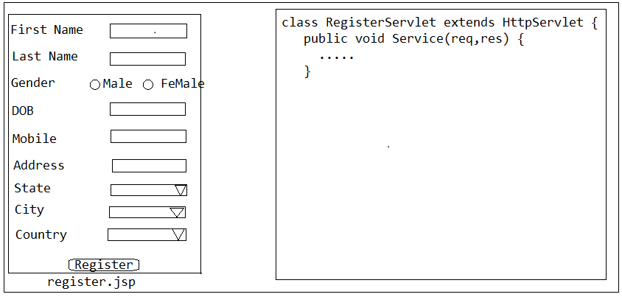

Note:

Populate the States and Cities data form the DB in to the JSP page dynamically bcz we should not hard code any data in the JSP (even it accessing data from DB or File) and we should not the java code in the JSP page.

🡪In DB there will be 2-types table.

1. Master Tables

2. Operational Tables

🡪Master tables are tables which contains the business data to run the application and which is populated by the business user or application Admin people and this data remains same or constant that there will be less amount of chance to change the data.

🡪Operational tables are tables which can be filled by the end users.

🡪Whenever we submit the register button on jsp-page then request goes the Servlet-Container and container is responsible to forward that request to that corresponding servlet.

🡪If we place the logic to load the data once in the Filter or Listener and binds in the req/context scope then J2EE application classes only can access the data that is there with in the Cache but Non J2EE applications cannot access the data so should not place with in the J2EE scopes that’s where we need to place in the Cache so that any class can access it.

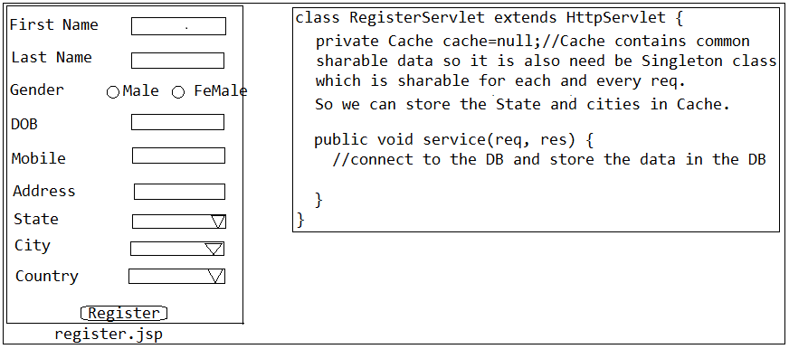

🡪Irrespective any req’s are coming to the application the data that is there with inn the Master tables will not change so we need to go for every time to fetch and populate the for every req form the DB rather we can retrieve once and we can place within the Cache so that DB calls will be reduced and performance issues can be avoided. Instead loading data at the 1st req we can load the Cache during the start-up of the application of in Listener or static block etc so that 1st req will also will not required to load the Cache so that 1st req also served without any waiting.

**Note:**

We should not store the data in Cache in any manner rather we need to sore the data in well-organized manner that means if at all we wanted to store the data in the Cache that can be easily accessible. If we wanted to store the cities and city code and states and state codes then just we should store like key and value bcz we cannot easily identify which is city code and which is state key so we need to place the states codes in an states key which contains all the state codes and state values, we need to store the cities as key and which contains the city code and values so that we can easily get the states or cities and from that cities and states we can easily get the whichever we want. That means we need to store the data with a global key factor-name so that we can easily get the data from the Cache.

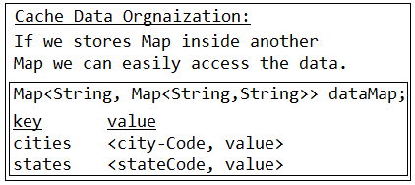

🡪Why always req comes to the servlet-container why can’t we directly forward to the corresponding servlet:

If we directly forward the req to the servlet directly then programmer need to write the infrastructure logic receiving the req over the network by opening the server socket. i.e We know that every servlet is going to read the data from an network so, the programmer need to write the logic in servlet to read the data from the network. If programmer is writing this common logic in all the servlets then this logic will be duplicated across all the servlets hence servlet-container came into picture.

Servlet container negotiates the receiving the req over the n/w and communicates with underlying protocol and extracts the data that is send over the n/w but servlet container will don’t how to process the req hence it forwards the req and extracted data to the corresponding servlet for processing the req. In order to forward the req to corresponding servlet by the container we need to override the container provided methods and we need to write this logic in the service method by implementing our class from servlet-interface or by extending from servlet-class then container creates the obj of our class and calls the methods bcz it only creates the obj.

In order to create the obj of our class by the container we need to configure these classes as servlets in web.xml by associating with url-pattern.

Note:

Servlet Container will identifies req is coming to specific application based on the Context Root (Project Name) of the application and followed by the accessing location that we have specified in the req URL.

Web.xml:

Web.xml is nothing but web-application deployment descriptor

i.e description info about the components that are deployed within this web-appl.

🡪We can deploy the following components within a web-appl

Servlets

Filters

Listeners are called as web-appl components.

Within the web.xml we will not permitted to configure all the classes, the classes that we wanted to be managed by the underlying servlet container only those are permitted to configure as part of the web.xml

The web.mxl is a configuration file which only holds the info about the components that are managed by underlying servlet container or it is the configuration file that contains only the web-appl related components that is the reason web.xml is called "web-appl deployment descriptor" and the name of the configuration file should be web.xml only otherwise servlet container will not identify the configuration file.

Note:

Instead of making a class as singleton like in use-case-1 we can also mark methods as static it is also one of the solution then we no need to create the obj and we can access those static methods using class name but still we can create multiple obj’s to those classes which does not contain any sense.

Ex:

calss A {

static m1() {

}

}

Static methods we cannot be override bcz they cannot inheritable.

Ex:

class B extends A{

private B(){

}

//singleton logic

m1(){

}

}

class C extends B{

}

It is wrong bcz, implicit super constructor B() is not visible for default constructor. Must define an explicit constructor. Hence it cannot extends from B bcz constructor of a class is private that is the reason if we wanted to use same methods that are there within the class B as override we need to declare m1() as in super class A then follows like this below.

class A {

m1(){

}

}

class B extends A{

private B(){

}

//singleton logic

m1(){

}

}

class C extends A{

m1(){

}

}

Note:

Static methods cannot be override.

🡪Did u worked on the JSP pages?

🡪No, Java developers are not responsible for to develop the JSP pages rather it is the job of the UI developers but if any data has to be loaded dynamically from the DB or properties file system then only we need add the logic in tags (using Jstl tags or custom tag libraries (but tag lib not using now a days) not in java) to display the data dynamically. We can tell there will be a separate UI team they will takes care of writing the JSP pages.

🡪How can we populate the in JSP dynamically at run time by reading from the DB?

Write the Servlet which is responsible for reading the data from the DB and places in one of the scope and forwards the req to the JSP page and in JSP we can use Jstl tags or tag libraries to retrieve the data that is there in the specified scope and iterate one after another and we can display as part of JSP page.

🡪Can u plz list down few of the class names of your project which are singleton?

Rather than saying class names we can say I think the question u r asking about which classes we can make it as singleton if I am not wrong that is u want you are expecting I think (ask in an respect manner and in an experienced way) so we can tell the answer when we can make a class as singleton at this time we can tell this use case. If at all insisting us to tell some names we can tell names if we know but don’t tell names max time in an interview bcz they will not expect code from us. So we can say in our project most of the times

1. All the utility classes

2. All the validator classes (if have observe form project)

3. All the converter classes (converting INR-$, CM-KM vice versa) and other any classes

Which doesn’t have any state and read only such type cases we make as singleton.